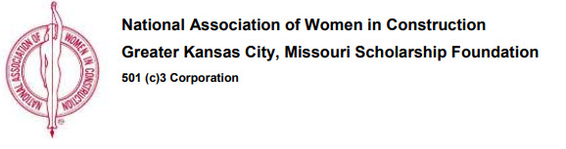

The National Association of Women in Construction Scholarship Foundation of the Greater Kansas City, Missouri Chapter 100 will be accepting applications from students who are pursuing a degree in a construction-related field. One change we would like to make you aware of from past years is that NAWIC student chapter members are eligible for the scholarship as long as an immediate family member is not a member of any NAWIC chapter.

Applications with official transcripts must be postmarked by March 31, 2019 and mailed or e-mailed to:

Debbie Hoover
13730 W 108th Street
Lenexa, Kansas 66215
dhoover@prosserwilbert.com

Applications are available in hardcopy in the Department Office (S 2049) or
on the department website for download (two pdf versions, one printable and one fillable)

