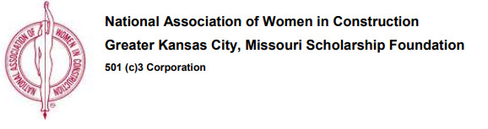
NAWIC Wichita Scholarship Foundation

The National Association of Women in Construction Wichita Chapter Scholarship Foundation will be accepting applications from students who are pursuing a degree in a construction-related field. This scholarship is open to students pursuing careers in Architecture, Architectural Engineering, and Construction Management.

Applications with official transcripts must be postmarked by March 31, 2019 and mailed or e-mailed to:

NAWIC – Wichita Scholarship Foundation
P.O. Box 48793
Wichita, Kansas 67201
jana.m.forrest@emcins.com

Applications are available in hardcopy in the Department Office (S 2049) or
on the department website for download

